# DATA ANALYTICS

## Description of the Data set:

Acme Telco is a small telecom company that develops, sells, and installs telecommunication devices such as network routers, conference call hardware, etc. for business needs. Acme has been operating for over a decade with a modest current headcount of close to 200 people and it has organized itself around the following 5 departments: Operations, IT, Sales, Software engineering, and Admin.

Mrs. Ramsey has thought about the implications of the study carefully and in order to be specific about the findings and save time she wrote down a few areas that needed to be explored carefully.

As a Data Scientist, you are expected to conduct analysis on the lines of these managerial questions and find answers.

We have been created a '3' data sets containing:

(1) Basic Employee Data, (HRIS-1)

(2) Employee performance and attendance data (HRIS-2)

(3) Employee Salary data (FIS)

**Preparing the data for Tableau**

Before going to do visualization we need to do connection between the data sets, In this process we have facing any issues we can clean it up by drag and drop.

**CONNECTING:**

1. Connect tableau by selecting Connect.

à To a file.

àMicrosoft Excel.

àSelect file and open.

1. In this all sets we have equal no.of rows and employee ID is available in all sets.Now we can do any join operation like data blending or combine with using relationships.
2. Now we can do combine with relationships.
3. We need to bring HRIS-1 to the table section because its having more information than other 2, After that we can go with HRIS-2 and IFS, Tableau will automatically use Employee ID to connect the tables.

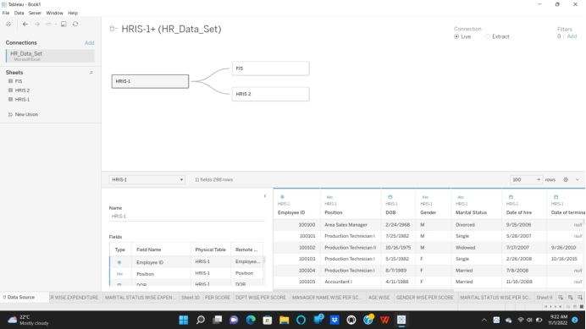

After establishing a successful connection the result will be like this after this we can move forward to Data Analytics part for company expectations

**Group size and demographics:**

1) How many employees are currently employed by each department?

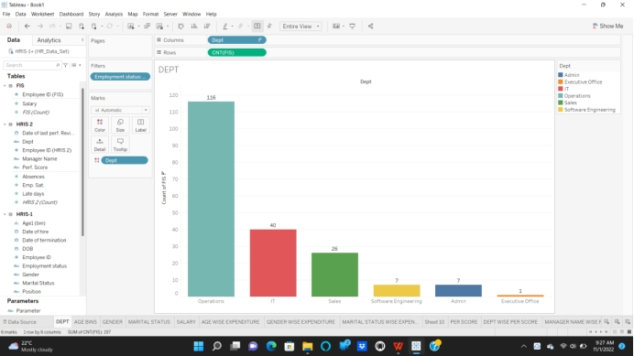

● Move Dept to Columns and any count to rows.

● Move employee status to filter and click active status.

● For colour drag Dept to colour, And go for Analytics and show mark Labels .

● Sort the bar chart in the descending order.

**Insight:**

According to the above bar chart, More no.of active employees are from Operation Department as 116, Where as IT 40, Sales as 26, Software Engineering and Admin as 7, The least no.of active Employees are from Executive Office.

2. What are the demographics of our current employees?

i. Age

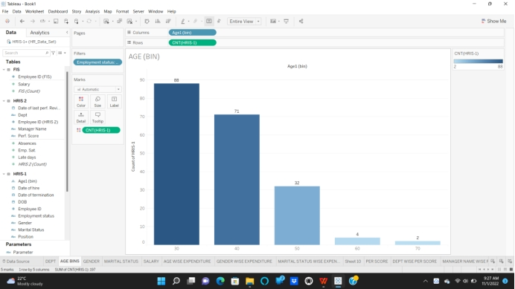

● Create a calculated field called ‘Review Date’ with text ’31-Dec-2022’

● Create a calculated field to compute age (‘Age’) with the following calculation:

**ROUND(([Review date]-[DOB])/365,0)**

● Create bins for ‘Age’ with size 10.

● Bring Age(bin) to columns and count to rows.

● And put Employee Status as active, And go for Analytics and show mark Labels.

● Give an colour and sort the chart.

**Insight:**

According to the above chart the most no.of employees are belongs to 10-30 years with 88 Employees followed by 30-40 years,40-50 years,50-60 years,60-70 years with

71,32,4 and 2 Employees respectively

2. What are the demographics of our current employees?

ii. GENDER

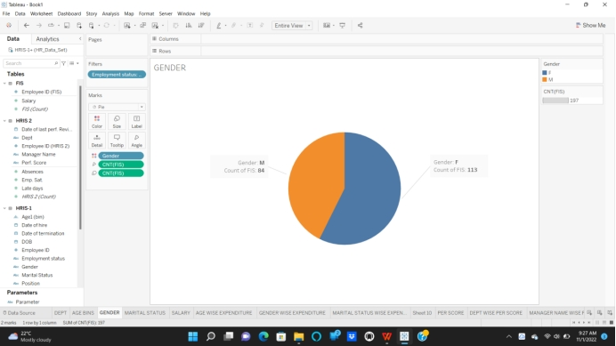

● Move Gender to columns and Count to Rows.

● Click Show Me and go for pie chart.

● And put Employee Status as active, And go for Analytics and show mark Labels .

● Move Count to Angle.

● Change Standard view to Entire view.

**Insight:**

From the above pie chart Female Employees are more than male Employees

as Females 113 and males 84.

2. What are the demographics of our current employees?

iii. MARITAL STATUS

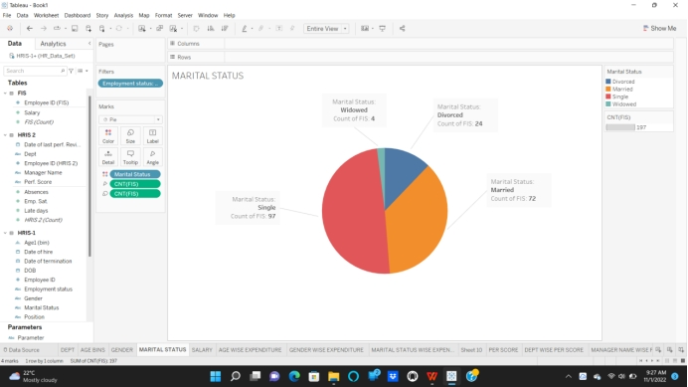

● Move Marital Status to Columns and Count to Rows.

● Click Show Me and go for pie chart.

● And put Employee Status as active, And go for Analytics and show mark Labels.

● Change Standard view to Enter view.

**Insight:**

From the above pie chart, We can observe 4 different Fields Single, Married, Divorced and Widowed as 97,72,24 and 4 respectively.

The more no,of Employees are in singles after that Married as we can conclude.

**Salary Structure :**

3) What was the current total salary expense for each department?

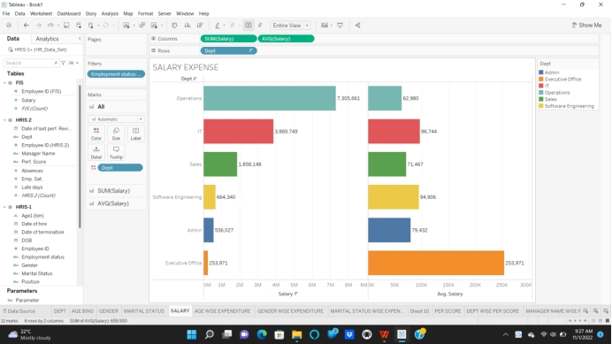

● Move Dept to Rows and Salary to columns.

● Duplicate the salary and give right click and change Measure to Average.

● And put Employee Status as active, And go for Analytics and show mark Labels.

● Move Dept to colors.

● Sort the chart and go for Entire View.

**Insight:**

From the above Bar Graph, We can conclude that more salary earning by

Operations field as 7 305 661 and Average as 62 980, After this IT as 2 889 749 and Average as 96 744, After this Sales as 1 858 148 and Average as 71 486, After this one Admin having 556 027 as salary and 79 432 as Average. Now the last one Executive Office, Salary and Average are same as 253 971 same because there only one Employee working.

4)What is the salary structure for each demography of our current employees?

1. Age

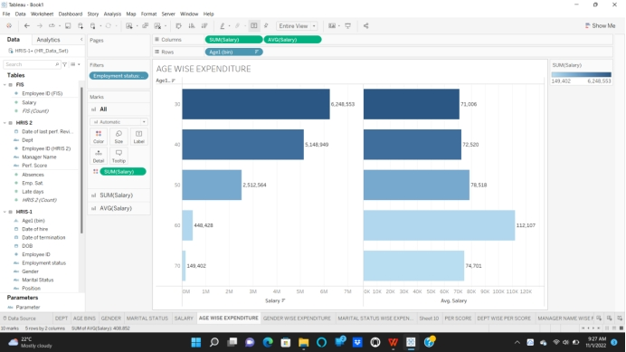

● Move Age(Bin) to Rows and salary to Column.

● Duplicate the salary and give right click and change Measure to Average.

● And put Employee Status as active, And go for Analytics and show mark Labels.

● Move Salary to colors.

● Sort the chart and go for Entire View.

**Insight:**

From the above Bar Graph, We can see Age bins as 30 distance

From 0-30 as 6 248 533 and Average as 71 006, This only only having more salary compared to others as least 60-70 as 1 49 402 and 74 701 respectively. 0-30 is earning more salary because there are more Employees in that age Range.

4) What is the salary structure for each demography of our current employees?

ii) GENDER

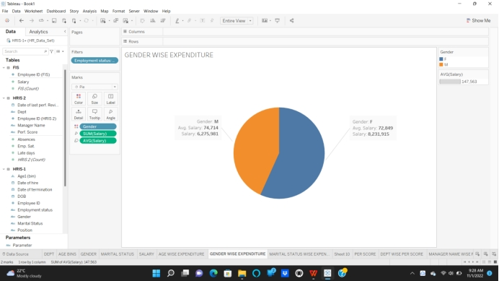

● Move Gender to Columns and Salary to Rows.

● Duplicate the salary and give right click and change Measure to Average.

● Click Show Me and go for pie chart.

● And put Employee Status as active, And go for Analytics and show mark Labels.

● Change Standard view to Enter view.

**Insight:**

From the above Pie Chart, There are 2 fields Male and Female’s salary expenditure as 6 275 981 and 8 231 915 as Salary and having Average Salary as

74 714 and 72 849, There we can observe Females are earning more salary compared to Males because there are more no.of Employees in the company that’s why there salary is high and its comes to Average salary Males are having high because they are low in count but high in earning.

4) What is the salary structure for each demography of our current employees?

iii) MARITAL STATUS

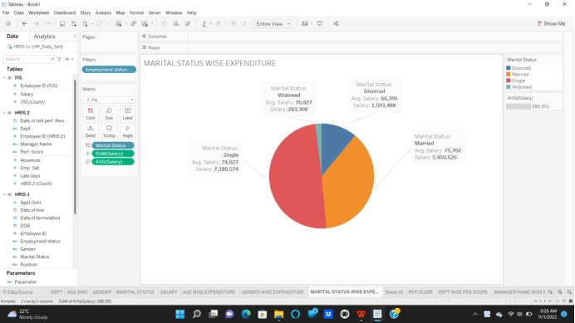

● Move to Marital Status Columns and Salary to Rows.

● Duplicate the salary and give right click and change Measure to Average.

● Click Show Me and go for pie chart.

● And put Employee Status as active, And go for Analytics and show mark Labels.

● Change Standard view to Enter view.

**Insight:**

From the above Pie Chart, Salary expenditure of 4 categories from the marital status as Singles with 7 180 574 salary and 74027 Average, Married with 5 450 526 salary and 75 702 Average, Divorced with 1 593 488 salary and 66 395 Average, Widowed with 283 308 salary and 70 827Average. After comparing all Fields we can conclude Singles having high Salary Expenditure

**PARAMETER:**

5) Applying parameter for salary structure.

1. DPARTMENT

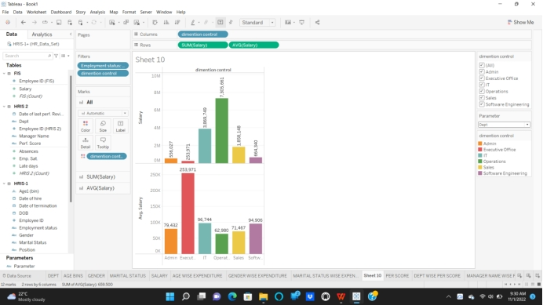

**CREATING PARAMETER:**

At the top left side, Right side of search bar there is an down arrow, Click that one and go for Create parameter give the parameter name. Select data type as String and click apply, And click to Add Data and select Dept, Gender, Marital Status, Position

**CREATE AN CALCULATED FIELD:**

Dim Control as code

CASE [Parameter ]

WHEN 'Dept' THEN [Dept]

WHEN 'Gender' THEN[Gender]

WHEN 'Position' THEN[Position]

WHEN 'Marital Status' THEN [Marital Status]

ELSE ' '

END

● Move Dim Control to Column and salary to Rows.

● Duplicate the salary and give right click and change Measure to Average.

● And go for Analytics and show mark Labels

● And put Employee Status as active and Dim Control to filter.

● Give right click to parameter and Click Show Filter.

● Move Dim control to colour and select Dept from the parameter as left of sheet.

**Insight:**

From the above Bar Graph Operations Dept having high salary expenditure and Executive Office having high Average because only one Employee working there.

5) Applying parameter for salary structure.

1. MARITAL STATUS

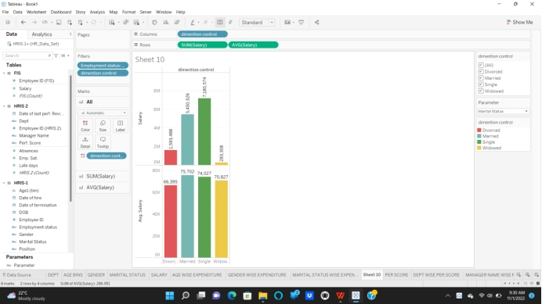

● Move Dim Control to Columns and Salary to Rows.

● Duplicate the salary and give right click and change Measure to Average.

● And go for Analytics and show mark Labels.

● And put Employee Status as active and Dim Control to filter.

● Give right click to parameter and Click Show Filter.

● Move Dim control to colour and select Marital Status from the parameter as left of sheet.

**Insight:**

From the above Bar Graph Singles having high salary expenditure compared to all Fields but the Married Employees are having high Average compared to singles.

5) Applying parameter for salary structure.

iii)POSITION

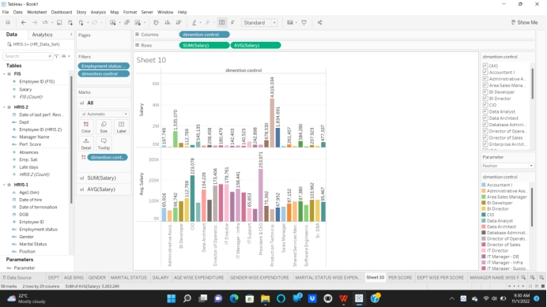

● Move Dim Control to Columns and Salary to Rows.

● Duplicate the salary and give right click and change Measure to Average.

● And go for Analytics and show mark Labels.

● And put Employee Status as active and Dim Control to filter.

● Give right click to parameter and Click Show Filter.

● Move Dim control to colour and select Position from the parameter as left of sheet.

**Insight:**

From the above Bar Graph the high salary earning by Production Technician I

And high Average gain by Precedent & CEO. Finally the high expenditure gain by

Production Technician I from the above Graph.

5) Applying parameter for salary structure.

iv) GENDER

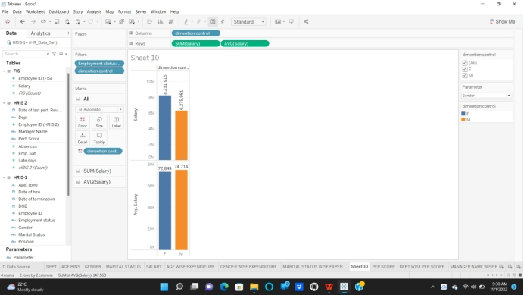

● Move Dim Control to Columns and Salary to Rows.

● Duplicate the salary and give right click and change Measure to Average.

● And go for Analytics and show mark Labels.

● And put Employee Status as active and Dim Control to filter.

● Give right click to parameter and Click Show Filter.

● Move Dim control to colour and select Gender from the parameter as left of sheet.

**Insight:**

From the above Graph Female Employees are having high expenditure of salary compared to Male Employees and Male Employees having high Average rate compared to Females. Finally Females having high salary Expenditure compared to Male Employees

**Performance Results:**

6)What was the distribution of employees in terms of their performance?

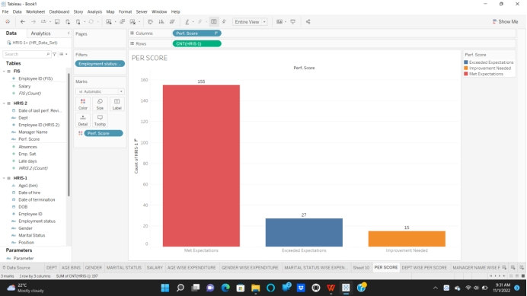

● Move Perf. Score to Columns and Count to Rows.

● And filter Employee Status as Active.

● And go for Analytics and show mark Labels.

● Move perf. Score to colors.

**Insight:**

From the above Bar Graph performance score of total Employees as shown as Met Expectations as 155 , Exceeded Expectations as 27 and Improvement Needed

As 15. At the end of the concluding more Employees are reached the Met Expectation reached.

6)Could we do a deep dive per group?

1. DEPARTMENT

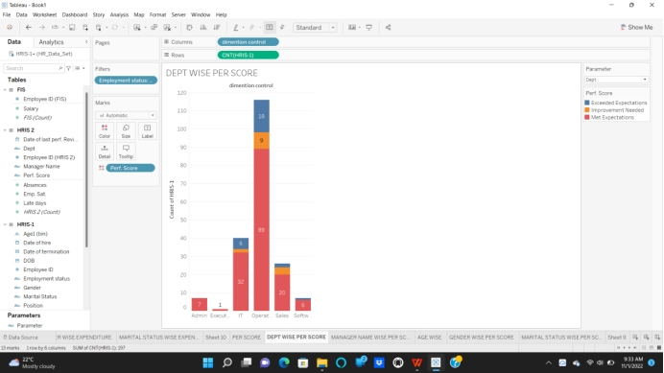

● Move Dim Control to Column and Count to Rows.

● And filter Employee Status as Active.

● And go for Analytics and show mark Labels.

● Move Perf. Score to colors.

● Give right click to parameter and Click Show Filter.

● Move Dim control to colour and select Dept from the parameter as left of sheet.

**Insight:**

From the above Bar Graph, Operations Met Expectations as 89 high from the all departments and also Operations made Improvement Needed as high with 9 and again Exceeded Expectations as 18 high from all Departments. Finally Operations having high Employees from the all Categories.

6) Could we do a deep dive per group?

ii) AGE

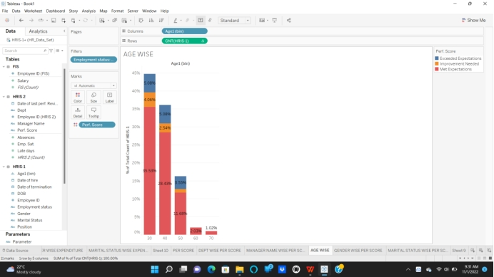

● Move Age(bins) to column and count to Rows.

● Drag perf.score to colours.

● Put employee status as active and sort the graph.

● And go for Analytics and show mark Labels.

**Insight:**

From the above bar graph, We can see the demography of employee as per age wise

Performance score, We can observe that, Employees with in 30 age are having more performance score compared to other 40,50,60 and 70 age employees.

6) Could we do a deep dive per group?

iii) Gender

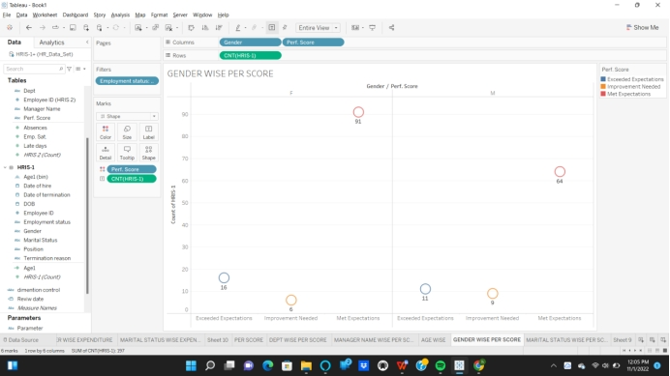

● Move Gender to Columns and count to Rows.

● Now move perf.score to Column and move one more perf.score to colour.

● Move count to text labels and Employee status as Active.

● Open show me and select side-by-side-circles.

**Insight:**

From the above side-by-side-circles chart, The Gender wise performance score is taken. Where Female employees reached met Expectation with 91 members, Where males having only 64.

6) Could we do a deep dive per group?

iv) Marital Status

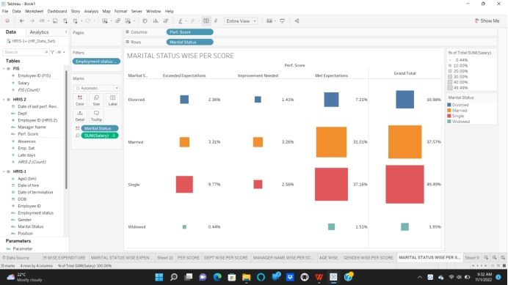

● Move perf.score to columns and Marital Status to Rows.

● Drag Marital Status to colours and Employee status as Active.

● Now open Show me and go for Heat Mapes and select it.

● Now go with analysis select percentage of table.

● Now from Analytics go for total in columns.

**Insight:**

From the above Heat Map, We can observe the perf.score by Marital status wise the singles having more number in count so the single Employees having more perf.score then married with 37.16% out of 49.49% where married having 31.01% out of 37.57%, From the above map we can said singles have more perf.score.